

**Fishing emotions at the RYBOMANIA Angling Fair**

The Rybomania Angling Fair will be held on March 3-5, 2023 in Poznań. Preparations are gaining momentum. Significant companies from the angling industry have already confirmed their participation, and there will also be new brands that are planning to enter the market. An exciting meeting is coming!

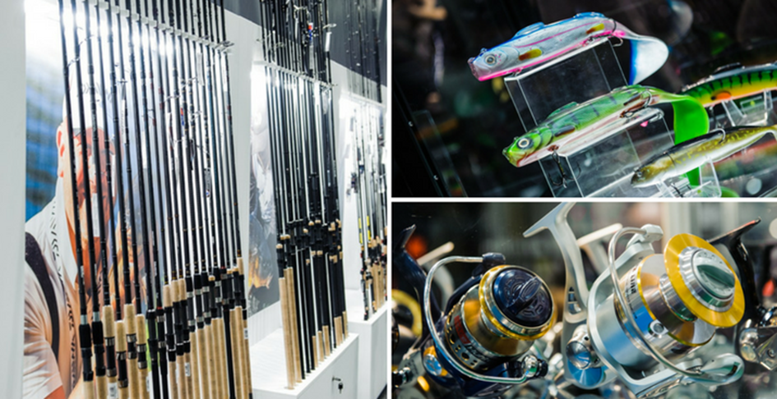

RYBOMANIA has been considered a symbol of the beginning of the fishing season for eleven years. Every edition, several hundred new products appear at the Poznań exhibition, which set trends in Polish waters, both in terms of fishing and tourist equipment. This year's edition of RYBOMANIA, which we had to wait 3 years for, promises to be extremely impressive. Among the exhibitors there will be producers and distributors of fishing equipment of well-known brands, and also handicraft products. Companies will present new products, including premiere models of fishing equipment and a wide range of tourist equipment and outdoor clothing.

As during every edition of RYBOMANIA, there will be meetings with fishing masters, during which you will be able to talk about equipment, unusual fisheries and big fish. Participants of the RYBOMANIA Fair will establish business contacts and prepare for the upcoming season. The exhibition will be complemented by representatives of the industry and the most important press in the fishing industry unions and associations.

The fair in Poznań on March 3-5 is preceded by the opening of the fishing season. “Poznań is always a unique place for us to organize RYBOMANIA. Here, exhibitors are preparing market novelties, and after the winter season, anglers can't wait to check what they bought" - says project director Miłosz Jankowiak.

RYBOMANIA has become a permanent fixture in the fishing calendar. For exhibitors – producers and distributors of fishing equipment it is a great opportunity to get to know the preferences of recipients. It is a holiday for anglers - days filled with great emotions, which are aroused by the latest models of rods and reels, as well as meetings with experienced anglers. It is also an event that allows you to get to know the beauty of nature and shapes attitudes aimed at its protection.

Entrance to the RYBOMANIA Fair for visitors will be available from the Northern entrance - from ul. Grunwaldzka. A detailed map of the event can be found at [www.rybomania.com.pl](http://www.rybomania.com.pl).

**OPENING HOURS**

**Friday, March 3 (VIP DAY) - 10:00 – 18:00**

**Saturday, March 4 - 10:00 – 17:00**

**Sunday, March 5 - 10:00 – 16:00**

Tickets: <https://mtp-link.pl/pyye9>

More information: [www.rybomania.com.pl](http://www.rybomania.com.pl)

Contact for the media and sending invitations to journalists:

natalia.porozynska@grupamtp.pl, paulina.kajewska@grupamtp.pl