**Rybomania 2025 - the fishing season starts on 7-9 March in Poznań!**

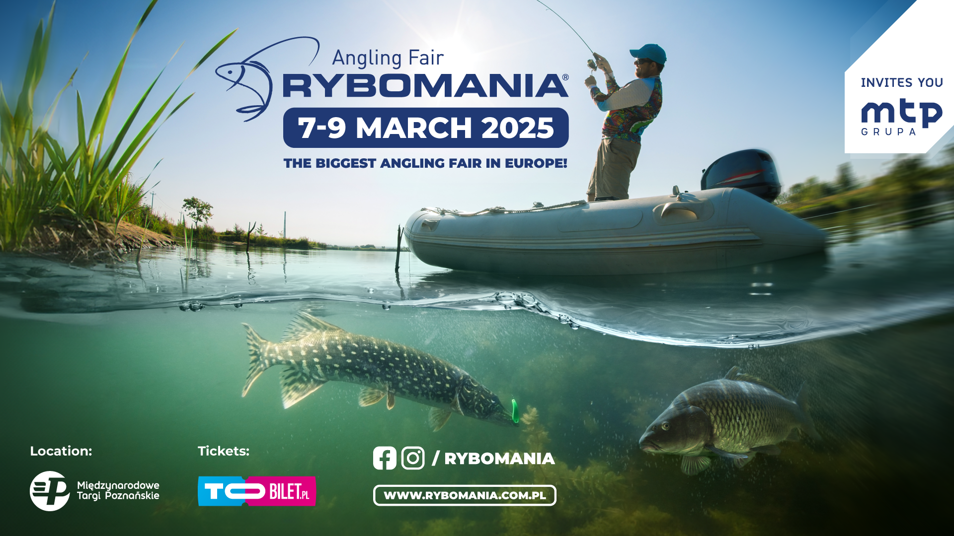

**From 7-9 March the biggest event for the fishing industry in Europe will take place: RYBOMANIA 2025. The best manufacturers and distributors of the fishing industry and enthusiasts from Poland and Europe will meet at the Poznań MTP Expo.**

The Rybomania trade fair will traditionally open the new season! Once again, there will be plenty of excellent equipment, lures, accessories, angling and tourist clothing from the best manufacturers, tents, beds, seats, boats and pontoons. There will be a lot to choose from for professionals and hobbyists of every fishing method, in particular carp, catfish fishing, method feeder or spinning. Additionally, during next year's edition, it is planned to expand the subject of fly fishing.

**Edition 2024 – biggest angling fair in Europe**

In 2024, the angling community came to Poznan in an **outstanding number of 31,748 participants**, who came from **more than 20 countries** for these three special days, making Rybomania 2024 the largest event of its kind in Europe. The stands of manufacturers, distributors and shops presented themselves exceptionally richly: the latest models of rods and reels, lures, new fishfinders and the Polish premiere of an innovative bait boat were just some of what the exhibitors offered. You could also see new models of touring beds, tents and clothing, new electric and combustion engines. RYBOMANIA also featured a unique curiosity - a boat created by the VIKING company especially for the people with disabilities. **More than 250 exhibitors from 12 countries** presented their offers. On the main stage, **celebrities and angling experts shared their experiences and knowledge**; speakers included: Jakub Vagner, Ross Honey, Kamil Walicki, Radosław Witólski, Robert Adamski, Piotr Boufal, Rafał Mleczak, Tomasz Lewandowski, or Monika and Łukasz Lechowscy; the winners of prestigious competitions, including Stairs2Hell and Polish Carp Masters 2023, also met with the audience. In addition, on the first day, a conference was held with the participation of scientists from the University of Warmia and Mazury. Another interesting point was the inauguration of the auction of a jubilee catamaran made on behalf of the MEUS company on the occasion of the 25th anniversary of the World Carp Classic competition.

**A community united by adventure**

The upcoming edition (7-9 March 2025) will once again be a venue for angling in every sense of the word: business relations, friendships, meetings with celebrities, but also those first ‘encounters with a fishing rod’ for complete novices and the youngest participants in the Fair. *It never gets boring - watching passionate visitors with a twinkle in their eye as they make their way through the pavilions, high-fives at every turn, laughter and enthusiastic voices. Each edition is seemingly the same event, but each time it evokes a very fresh, strong impression*, says Miłosz Jankowiak, RYBOMANIA project director.

RYBOMANIA is an event based on the presence of the most important brands and angling shops on tens of thousands of square metres of exhibition. The exhibitors will once again include leading manufacturers and distributors of angling equipment and accessories, as well as angling shops. Complementing the exhibition will be, as always, offers from fisheries, craftsmen and companies in the fishing tourism and fishing equipment sectors. Next year's edition will be held (this is a change from the 2024 edition) in pavilions 3, 3A, 4 and part of pavilion 5.

Among the inherent attractions of RYBOMANIA there will be the Giant Aquarium. A tank of almost   
20 000 litres filled with specimens of Polish fish, ‘testing’ the equipment of the best companies and the skills of outstanding anglers in front of the eyes of the audience. As always, the programme of events includes a lecture stage with presentations by the most recognised authorities in various fields of angling, as well as another edition of the Young Angler's Academy addressed to children and aimed at igniting their passion for angling while respecting the natural environment.

The RYBOMANIA trade fair is, above all, a huge community whose common denominator is the desire for adventure, extraordinary emotions and, of course, the anticipation of the fish of a lifetime. It is a meeting place for enthusiasts - both those with many years of experience and vast knowledge, and those who are yet to write their fishing history. It is also an event that allows you to get to know the beauty of nature and shapes attitudes aimed at its protection, as well as a place to discuss current environmental issues. We encourage you to reserve the date of next year's RYBOMANIA in your calendar - 7-9 March 2025 at the Poznań MTP Expo.

**Tickets available at**: [ToBilet.pl](https://tobilet.pl/rybomania-2025.html)

**More information**: [rybomania.com.pl](https://rybomania.com.pl/pl)

**Contact for the media and invitations for journalists**: natalia.porozynska@grupamtp.pl