**4 pavilions full of angling captures - thank you for the 13th edition of Rybomania!**

**The second weekend of March turned the 4 pavilions of the Poznań International Fair into a real paradise for anglers. Nearly 300 exhibitors, the latest equipment, shopping and testing is an opportunity that fishing enthusiasts wait for all year long. Plus attractions like a giant aquarium, the presence of fishing celebrities and interesting activities for children. From the weather, to top launches, meetings with well-known personalities, to impressions and excitement - everything played out this weekend!**

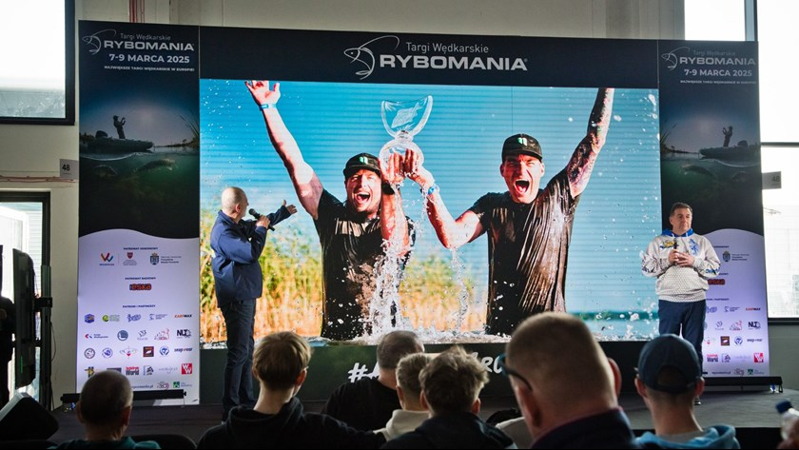

The Rybomania trade fair traditionally opened the new season on the waters. Everyone who likes to spend time fishing - whether professionally or purely as a hobby - found here everything they will need for the next few months: equipment, knowledge and inspiration for more frequent and effective expeditions.

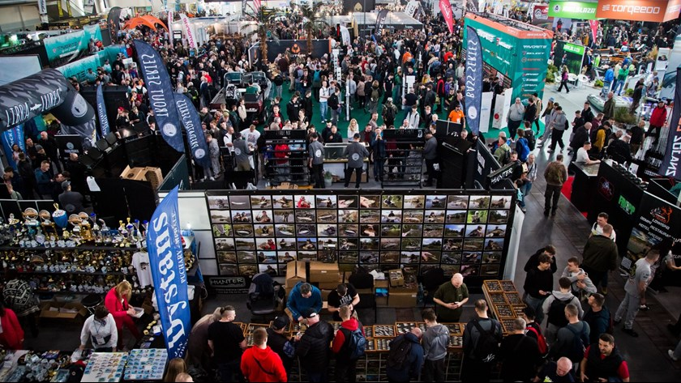

**More space, more exhibitors and more visitors....**

This year's edition of Rybomania Fair was held in pavilions 3, 3A, 4 and part of pavilion 5, gathering a **record number of visitors for the event - as many as 36,197 people**! Leading manufacturers and distributors of fishing equipment and accessories, as well as well-known fishing stores were again among **the nearly 300 brands present**, occupying an area of **more than 10,000 sqm**. Complementing the exposition were, as always, offers from fisheries, craftsmen and companies from the fishing tourism and fishing equipment sectors. At Rybomania there was no shortage of excellent products for every fishing method, lures, accessories, fishing and tourist clothing from the best manufacturers, tents, beds, seats, boats and pontoons. Enthusiasts of any fishing method, especially carp fishing, catfish fishing, method feeder, spinning or fly fishing, were sure to find something for themselves.

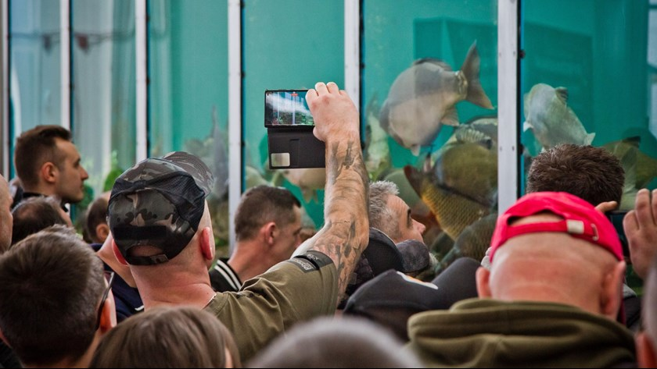

**A community connected by emotion**

Once again, Rybomania has become a meeting place for anglers on every level: business relations, camaraderie, meetings with celebrities, but also those first “meetings with a fishing rod” of complete novices and the youngest participants of the Fair. The fishing community - even though we already know it quite well - every edition surprises us with the enormity of its enthusiasm, passion and commitment to the subject. As the organizers of Rybomania, we are constantly fascinated by the incredible need for meetings, which we have the pleasure of realizing for a growing number of people. We are very pleased that anglers are hungry for news and take their passion very seriously, consciously approaching the whole process of fishing. - says Milosz Jankowiak, director of the RYBOMANIA project.

The exhibitors' booths, the main stage, and the shows at the aquarium and presentation pool featured well-known and beloved anglers and fishermen, who just here have the opportunity to meet face-to-face with fans - an invaluable experience for both parties, bringing together in an extraordinary way the relationships established over long distances in one place. It's also an opportunity to meet enthusiasts of all skill levels.

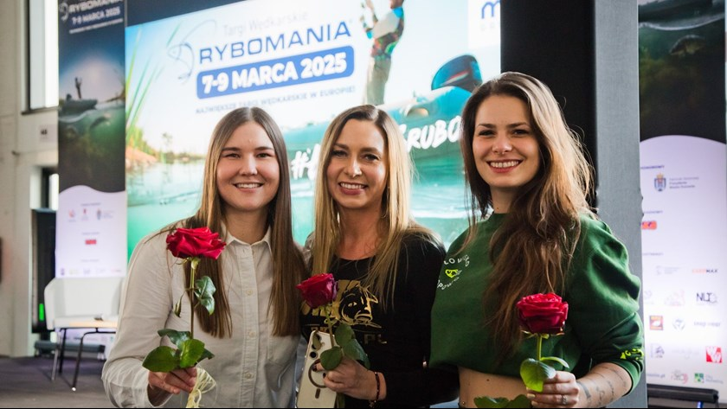

**Wędkarski Dzień Kobiet**

Traditionally the most visited day of the Rybomania Fair, Saturday, fell this year on March 8 - exactly on Women's Day! The second day of the Fair was therefore held under the banner of Angling Women's Day, which was a great opportunity to show that this is no longer just a “male” hobby - there are more and more female anglers (including professional ones) and they are not inferior in skills to men. In numerous lectures and meetings, women anglers spoke about their beginnings in this hobby, gaining experience, often great achievements, but also about the heath that discriminates against “women with fishing rods.” They also gave many clever tips on how the so-called “weak sex” can cope with outdoor inconveniences and harsh weather conditions.

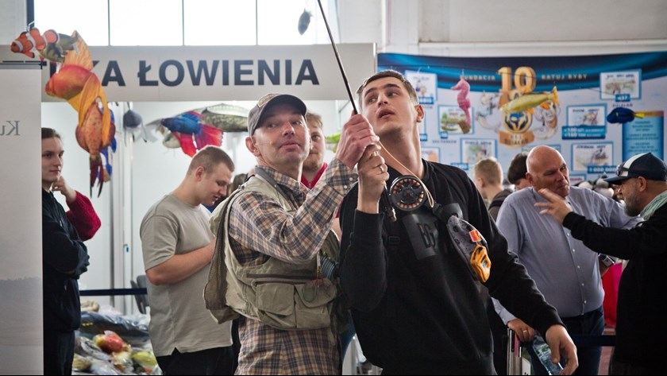

**Fly fishing - an interesting niche and a new adventure**

During this year's edition of Rybomania, the topic of fly fishing was significantly expanded. In pavilion 4 there was a 20-meter presentation pool, where demonstrations, lectures and equipment tests were conducted for 3 days. Experienced fly anglers and ichthyologists tried to infect people who had not yet had the opportunity to try this method, and shared their knowledge and best practices with the more experienced ones. Here it was possible to see how to tie, or create, so-called flies, and even rent a fly rod to try one’s hand at it.

**What's more?**

* Among the inherent attractions of Rybomania there was a Giant Aquarium. The tank of almost 20,000 liters was filled with dozens of specimens of Polish fish: carp, sturgeon, asp, bream, pike, zander, catfish and crucian carp, “testing” the equipment of the best companies and the skills of outstanding anglers before the eyes of the audience.
* In the program of events, the lecture stage took its strong place as always, with speeches by the most recognized authorities in various fields of angling, including, among others: Alan Blair, Jakub Vagner, Ross Honey, Kamil Walicki, Przemek Mroczek, Monika and Lukasz Lechowski or Lukasz “Tuszol” Tuszynski.
* The next edition of the Academy of Young Anglers this time involved as many as 11 partners and 5 sponsors! The action was aimed at children up to 10 years old, and for 2 days it pursued the goal of igniting in the youngest the passion for fishing while respecting the environment. The partners of the Academy provided quite a challenge - at each of them young anglers solved puzzles and tested their angling knowledge and skills, and the sponsors provided attractive prizes for the effort!
* A veritable plethora of online creators - this year's edition rolled out the “red carpet” for these more and less well-known fishing influencers. They were present both at exhibitor booths and in special zones.

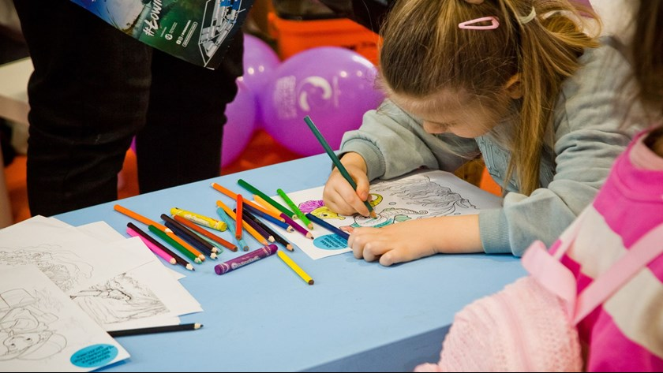

The Rybomania fair proved once again that anglers are, above all, a huge community, whose common denominator is the desire for adventure, extraordinary emotions and the anticipation of a fish of a lifetime. Rybomania is a meeting place for enthusiasts - both those with many years of experience and vast knowledge, and those who are yet to write their fishing history. It is also an event that allows you to get to know the beauty of nature and shapes attitudes aimed at its protection, and at the same time a place to discuss current environmental issues. All this and much more happened over the spring 3 days at the MTP Poznan Expo.